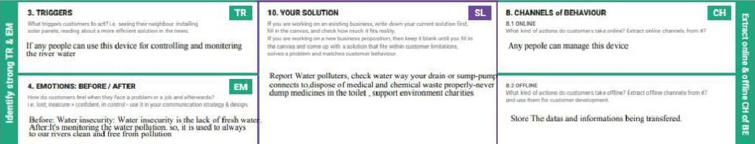Problem-Solution fit canvas 2.0 Purøose

